Facial Emotion Recognition using CNNs

Shahd Mohamed Hazber
Artificial intelligent and data science department
University of Ha'il
s202209766@uoh.edu.sa

Abstract
Sometimes when a person is talking to another person, they may use facial expressions without uttering a word - yet the other person understands them, but it may be a difficult challenge for computer algorithms to recognize human facial expressions, and more accurately. The objective of this research was to train a machine to identify human facial expressions with greater accuracy using Convolutional Neural Networks (CNNs). The dataset was obtained from Kaggle, and Python was used to create a model for facial emotion recognition employing a CNN algorithm. The dataset consisted of images capturing individuals displaying eight distinct emotions (anger, contempt, disgust, fear, happiness, sadness, surprise, and neutral). This model achieved a final accuracy of 69.57%.It expects that the facial emotion recognition will be more important and popular in the future, such as in the field of medicine, in the field of photography (Once tell the camera enhances the picture if a certain facial expression is shown in front of the camera without pressing any button), etc.
Keywords CNNs; Facial emotion; Facial recognition; python

1 Introduction
Facial expressions play a crucial role in human interactions and daily life. For instance, in a medical setting, a doctor may assess a patient's condition based on their facial expressions. According to Durai (2023), "Facial Emotion Recognition (FER) refers to the process of identifying and categorizing human emotions based on facial expressions. By analyzing facial features and patterns, machines can make educated guesses about a person’s emotional state."

  - Problem statement
Recognizing human facial expressions is a challenging task for computer algorithms. Firstly, computers do not possess emotions and lack the ability to comprehend what it means to feel happiness or sadness. Secondly, human facial expressions are highly intricate and nuanced, making accurate recognition difficult. The study of this subject is significant as Facial Emotion Recognition has potential applications in various fields, including customer service, healthcare, education—where it can enhance learning experiences by evaluating student engagement—and security.
1.2 The objective of the research
This research aims to utilize Convolutional Neural Networks (CNNs) to recognize human facial emotions. The proposed model implemented using Python, and its performance evaluated to determine its effectiveness.
1.3 The hypothesis of the research
CNNs, or Convolutional Neural Networks, are a class of artificial neural networks widely employed in deep learning and computer vision tasks. CNNs are particularly efficient in analyzing visual data and have demonstrated high success rates in tasks such as image recognition, object detection, and facial emotion recognition.

2 Literature Review
Facial expressions vary from person to person, and the brightness, contrast, and resolution of every random image are different. The article proposes an efficient system for facial emotion recognition for the seven basic human emotions using a convolution neural network (CNN), which predicts and assigns probabilities to each emotion. Since deep learning models learn from data, the authors’ proposed system processes each image with various pre-processing steps for better prediction. Every image was first passed through the face detection algorithm to include in the training dataset. As CNN requires a large amount of data, they duplicated their data using various filters on each image. Pre-processed images are passed as input to the first layer of CNN. Three convolutional layers were used, followed by a pooling layer and three dense layers. The model was trained by combining two publicly available datasets, JAFFE and KDEF. 90% of the data was used for training, while 10% was used for testing. They varied the number of CNN layers from 1 to 8 to find the best accuracy. The execution time increased with the number of layers without improving the accuracy. The trend of accuracy against the number of layers. Achieving 70.2% was achieved. So, they find that accuracy increases with the number of epochs. They evaluated state-of-the-art models like AlextNet, VGG, GoogleNet, and ResNet. In terms of accuracy, the proposed CNN models outperform existing standard networks. (Ghaffar, F. 2020)
Emotion being a subjective thing, leveraging knowledge and science behind labeled data and extracting the components that constitute it, has been a challenging problem in the industry for many years. With the evolution of deep learning in computer vision, emotion recognition has become a widely tackled research problem. The authors propose two independent methods for the purpose of emotion detection. The first one uses representational autoencoders to construct a unique representation of any given emotion. Autoencoders are a different class of neural networks that can reconstruct their own input in some lower dimensional space. Based on the results of previous publications, they decided to create a CNN on their own and train it from scratch. They created an 8-layer CNN with three convolutional layers, three pooling layers, and two fully connected layers. All the images in the training set were of Japanese women, so, all the samples come from the same ethnicity and of the same gender. Considering that, the results of the autoencoder part were decent. They also combined a number of 64 x 64 images and condensed them into a 300-d (or) 500-d space. On the JAFFE test set, the shallow model predicted 25 correctly out of 54, while the dense model did a little better getting 29 correct. On the LFW data set, these 300 nodes dense autoencoder model predicted 53 correct out of 105, couple of images more than the 500 nodes network. Since each test example must be reduced to 300/500 for testing, they made the number of iterations fixed for each example. The fluctuations in accuracies could be since the representations of some images might not have been fully learned. For the CNN model, the LFW test set predicted 71 out of 105 images correctly.
(Dachapally, P. R., 2017)
Detecting emotion from facial expression has become an urgent need because of its immense applications in AI such as human-computer collaboration, data-driven animation, human-robot communication etc. Since it is a demanding and interesting problem in computer vision, several works have been conducted regarding. The authors want in the research to develop a facial expression recognition system based on CNNs with data augmentation. They produce the idea of CNN with data augmentation and combined dataset collected from several datasets which leads this research to higher validation accuracy as well as higher and equal recognition rates compared to the existing models. The proposed model has achieved higher validation accuracy than any other existing model. The Graphical User Interface allows users to do real-time validation of the system. The authors have considered seven discrete and unique emotion classes for emotion classification.
(Ahmed, T. U., Hossain, S., Hossain, M. S., ul Islam, R., & Andersson, K. 2019)

3 Methods of the research
This research is quantitative research. It attempted to build a CNN model and train it on an album of photos of different genders, ages, and countries using Python and created charts and graphs for data visualization shows the distribution of genders, ages and countries. This includes several bases to achieve these goals:
3.1 Data collection from the open source (Kaggle)
It collected an album of photos of different genders, ages, and countries database which have 304 images of 19 different people models posing for 8 emotions. 80% of this dataset was used for training, and the rest for testing. The 8 emotions in the datasets are shown in the figure below.
  fear |   Natural |   Happy |   Anger
  Surprised |   Disgust |   Contempt |   Sad
Fig.1. Eight classes of emotions in the datasets (taken from Kaggle)
3.2 Data Visualization
Charts and graphs were created to depict the distribution of genders, ages, and countries before preprocessing the data. The distributions are shown in the figure below.

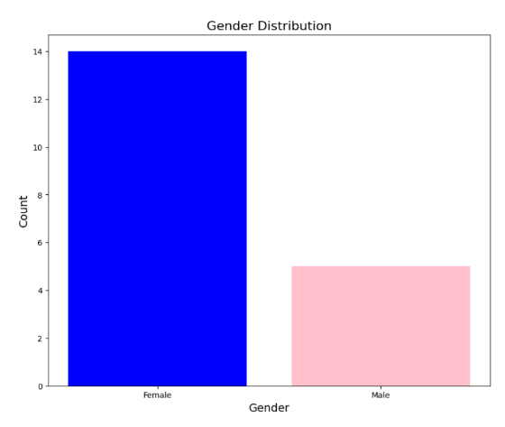
Fig.2 Gender Distribution

Figure 2 shows a bar chart to visualize the distribution of genders within a dataset called emotions_df. Took data on gender from a dataset, calculated the frequency of each gender, and then created a visually informative bar chart showing the distribution of genders with appropriate labels and titles. The color choices (blue and pink) further help to visually distinguish between the gender categories.
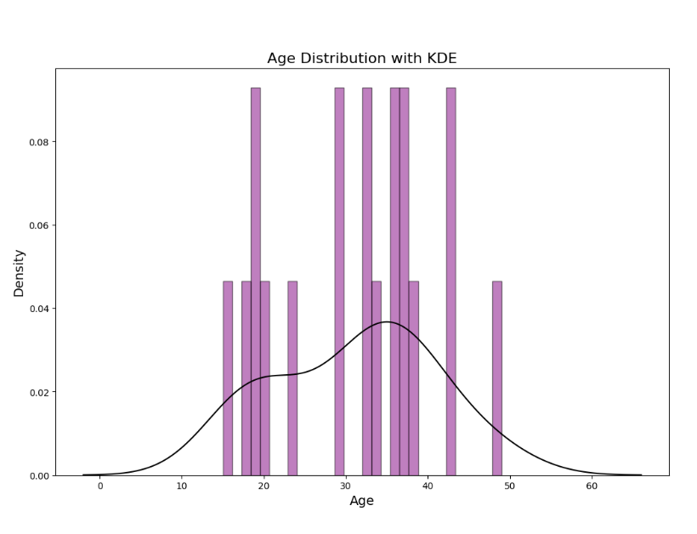 | 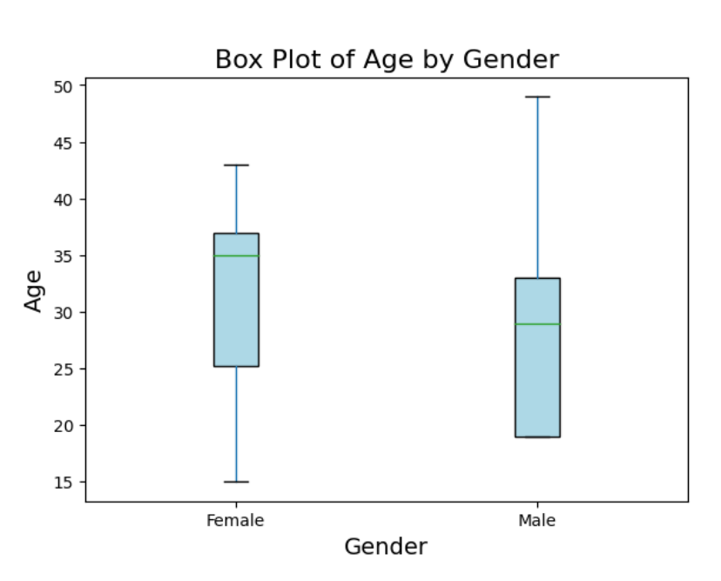
Fig.3. A. Age Distribution with KDE Fig.3. B. Box Plot of Age by Gender

Figure3. A. shows a box plot visualizing the distribution of ages between two genders (Female and Male) from data in a Pandas Data Frame called emotions_df. It customizes the plot's appearance, labels, and titles for clear and informative visualization.
Figure.3. B. shows a box plot visualizing the distribution of ages between two genders (Female and Male) from data in a Pandas Data Frame called emotions_df. It customizes the plot's appearance, labels, and titles for clear and informative visualization.

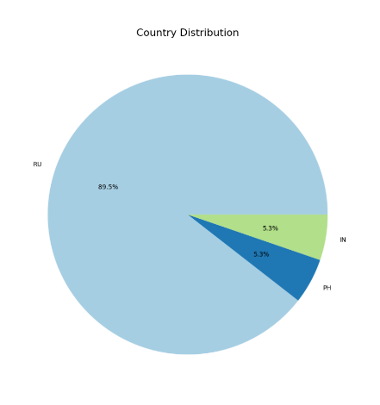
Fig.4 Country Distribution

Figure 4. shows a pie chart to visualize the distribution of data across different countries. Used libraries like matplotlib.pyplot (imported as plt) and potentially pandas (for the emotions_df Data Frame). Took a Data Frame containing country information, calculates the frequency of each country, and then uses this information to create and display a visually appealing pie chart representing the distribution of data across different countries.

3.3 Data Pre-processing
Defined a function called load_data () using the def keyword. This function is designed to load image data and their corresponding labels, for a machine learning task related to emotion recognition. (shown in Figure.5).
The load_data function systematically goes through directories representing different emotions, loads and preprocesses the images within them, and stores the image data and their corresponding emotion labels in two lists, making it ready for use in a machine learning model. And then performed two common preprocessing steps for image data and labels before feeding them into a machine learning model by normalizing the image pixel values. These preprocessing steps are essential for effective model training and performance.

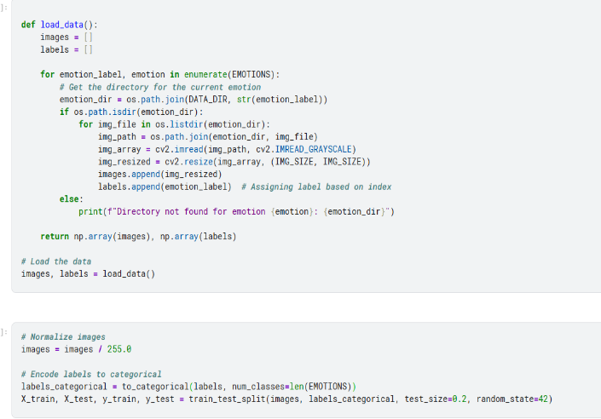

Fig.5 Function to load and preprocess images

3.4 Training model
Created a visualization with two subplots. One subplot shows how the model's accuracy changes during training (for both the training and validation data). The other subplot shows how the model's loss changes over time.
3.5 Result evaluation
Created a code for predicting and evaluating a model's performance using a confusion matrix and a classification report. These tools help in understanding how the model predicts different classes and provide insights into its strengths and weaknesses, and it is also used to visualizations to make the results easier to interpret.

4 Implementation
This experiment used a python and imported a library called Keras for creating CNNs model ,80% of the data used for training, while 20% used for testing. After splitting the dataset, a library called Keras used to build a Convolutional Neural Network (CNN) to classify images for emotion recognition (shown in figure.6.A). It trained the model using the data provided and evaluated its performance. The Accuracy for the model was 69.57%. Finally, created a code that takes a set of images (X_test), their true labels (y_true), and predicted labels (y_pred_classes), and created a grid of images showing the image along with its actual and predicted emotion label. It is used to visually assess the performance of an image classification mode (Shown in figure.6. B and 6.C).

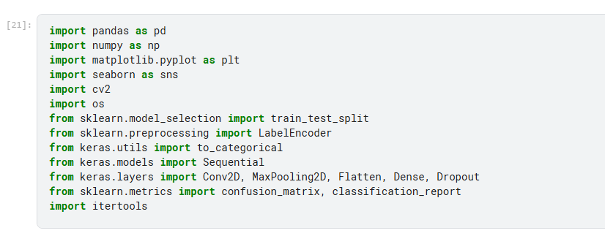 | 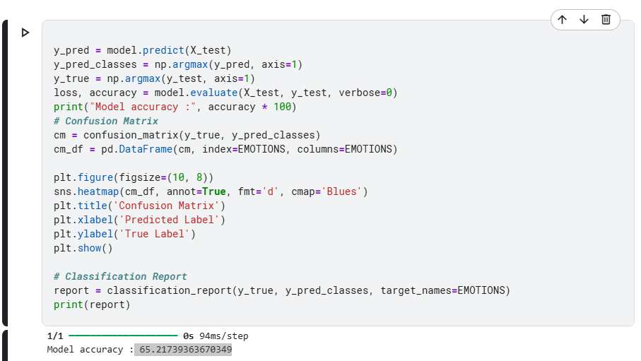 | 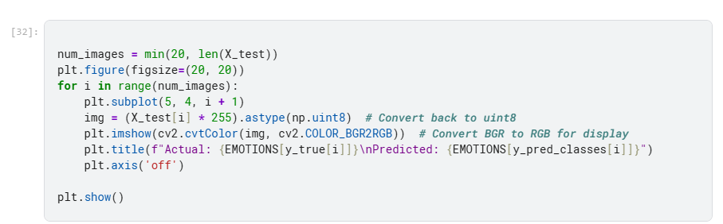
Fig.6. A. Importing libraries Fig.6.B. Traning model code Fig.6.C. Shows the images

Figure 6.A imported useful libraries for the project and (Keras) libraries for building CNN to classify images for emotion recognition. Figure.6.B code for training the model using the data provided and evaluated its performance, using a function that showed the accuracy of the model how it learned percentage. Figure.6.C shows the image along with its actual and predicted emotions label.
Created One subplot shows the model's accuracy changes during training (for both the training and validation data). The other subplot shows the model's loss changes over time. This visualization helped to understand how the model has learned and whether it might be overfitting or underfitting the data. The model accuracy and the model loss (figure.7). Output shown in the section results and discussion.
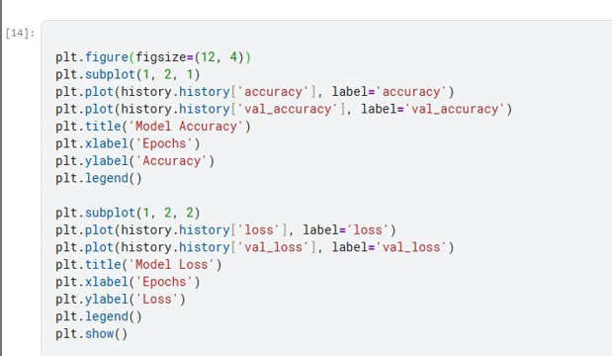
Fig.7 plot training history

5 Results and discussion
Figure 8.A and 8.B shows how the model learned and whether it might be overfitting or underfitting the data. In figure 8.A the blue line represented training accuracy, showed steady improvement across epochs. The orange line indicated validation accuracy, which also increased, albeit with some fluctuations. That means the model has learned effectively but might encounter inconsistencies when predicting unseen data. In Figure 8.B the blue line signified training loss, steadily decreasing as the model optimized predictions. The orange line represented validation loss, which follows a downward trend, but it showed slight fluctuations toward the end. This indicated potential issues with overfitting, where the model performed well on training data but struggled with generalization.
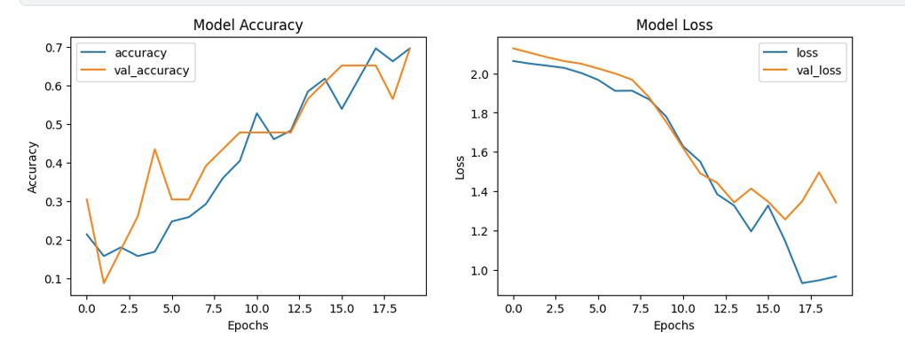
Fig.8.A Model Accuracy Fig.8.B Model Loss

Figure 9 the confusion matrix revealed the alignment and misalignment between the actual emotions (true labels) and predicted emotions (predicted labels). The correct predictions were “Anger” , “Contempt” , “Disgust” , “Happy” , “Neutral” , “Sad” , “Surprised” . “Happy” , “Neutral” , “Sad” and “Surprised” exhibited high accuracy. The misclassifications were “Disgust” , “Fear” , “Anger” . The model seemed to struggle with distinguishing between similar emotions like “Contempt” and “Disgust” .
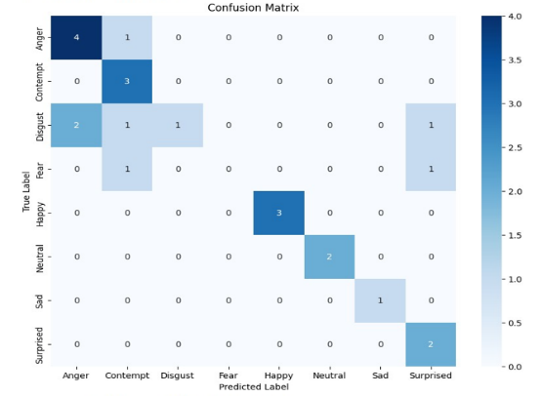

Fig.9 confusion matrix for CNN model
5.1 Evaluation result
Table.1. classification report
 | Precision | recall | F1-score | support
Anger | 0.67 | 0.80 | 0.73 | 5
Contempt | 0.50 | 1.00 | 0.67 | 3
Disgust | 1.00 | 0.20 | 0.33 | 5
Fear | 0.00 | 0.00 | 0.00 | 2
Happy | 1.00 | 1.00 | 1.00 | 3
Neutral | 1.00 | 1.00 | 1.00 | 2
Sad | 1.00 | 1.00 | 1.00 | 1
Surprised | 0.50 | 1.00 | 0.67 | 2
accuracy |  |  | 0.70 | 23
macro avg | 0.71 | 0.75 | 0.67 | 23
weighted avg | 0.73 | 0.70 | 0.64 | 23

In table 1 the evaluation result shows:
- Precision
Indicated how often the predictions for each emotion were correct. “Fear” has a precision of 0, means no correct predictions were made for this emotion, and strong precision is observed for “Disgust”, “Happy”, “Neutral”, and “Sad”.
- Recall
Measured the model's ability to identify all instances of emotion. “Fear” also has a recall of zero. “Contempt”,” Happy” , “Neutral” , “Sad” and “Surprised” have a strong recall.
- F1-score
Combine precision and recall into a balanced metric. “Fear” also has an F1-score of zero. “Happy” , “Neutral” and “Sad” have a strong F1-score.
- Support
Represented the number of instances of each emotion in the test dataset. Which is 5 instances of “Anger” and 1instance of “Sad”.
CNNs are particularly effective in handling grid-like data, such as images, due to their ability to capture spatial hierarchies in data. And the model achieved an accuracy of 69.57%. The model has a solid grasp on predicting emotions like “Contempt” , “Happy” “Neutral” , “Sad” and “Surprised” , as these have high true positive counts without much misclassification. The emotion “Fear” presented significant challenges for the model. This indicates a limitation in the model's ability to distinguish between these emotional states with sufficient precision.

5.2 Model prediction
Figure 10 shows that some of the emotions were consistently predicted accurately. For instance:
- Actual: Neutral, Predicted: Neutral.
- Actual: Surprised, Predicted: Surprised.
“Disgust” was often confused with “Anger” or “Contempt” . For example:
- Actual: Disgust, Predicted: Anger.
- Actual: Disgust, Predicted: Contempt.
“Fear” was particularly challenging for the model, being misclassified as “Contempt” or “Surprised” . For example:
- Actual: Fear, Predicted: Contempt.
- Actual: Fear, Predicted: Surprised.
The model excels at recognizing distinct emotions like “Happy” and “Neutral” , which have clear and unique facial features.
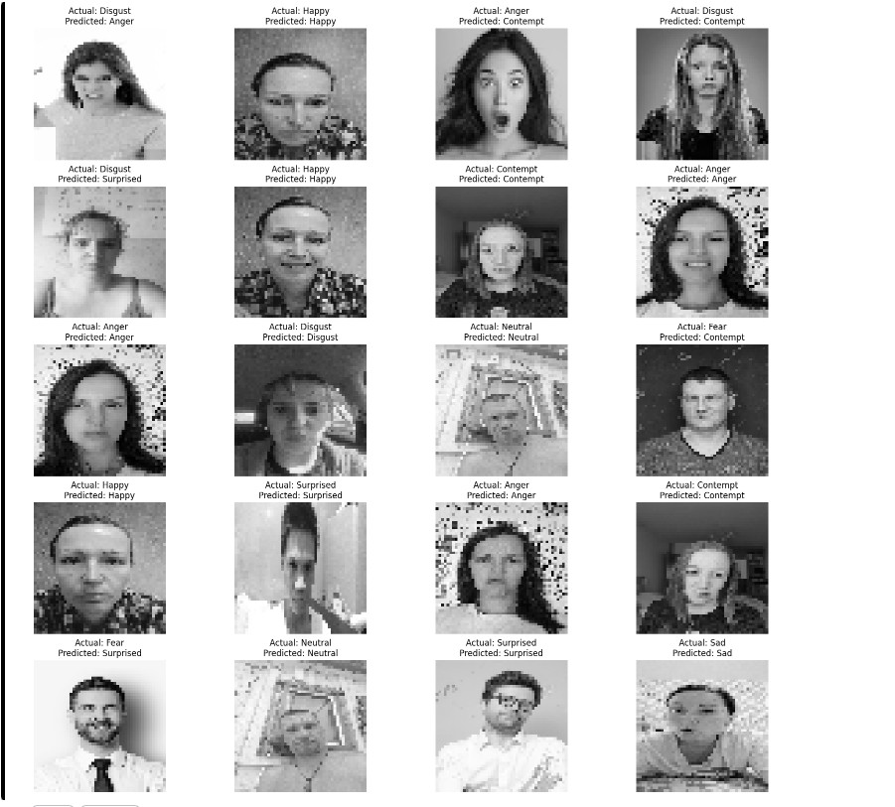
Fig.10. the predicted labels and the actual labels.

6 Conclusion and Future work
In this research, machine learning model is trained on the images dataset to identify human facial expressions using CNNs. It is particularly effective with a grid-like topology and proven to be successful in facial recognition through images capturing people displaying eight distinct emotions. After that, confusion matrix and classification report are used to predict and evaluate the model. The results of this evaluation are “Contempt” , “Happy” “Neutral” , “Sad” and “Surprised” shown have high true positive counts without much misclassification. The emotion “Fear” presented significant challenges for the model. The CNNs model achieved a final accuracy of 69.57%. In the future, will developing models capable of handling diverse datasets and enhance the recognition of subtle and complex emotions. The integration of this research into applications requires addressing ethical concerns, such as user privacy and data security. By ensuring transparency and responsible use.

Reference
Durai, P. (2023). Facial Emotion Recognition: Decoding Expressions.

Ghaffar, F. (2020). Facial emotions recognition using convolutional neural net. arXiv preprint arXiv:2001.01456.

Dachapally, P. R. (2017). Facial emotion detection using convolutional neural networks and representational autoencoder units. arXiv preprint arXiv:1706.01509.

Ahmed, T. U., Hossain, S., Hossain, M. S., ul Islam, R., & Andersson, K. (2019, May). Facial expression recognition using convolutional neural network with data augmentation. In 2019 Joint 8th International Conference on Informatics, Electronics & Vision (ICIEV) and 2019 3rd International Conference on Imaging, Vision & Pattern Recognition (icIVPR) (pp. 336-341).

Roman, K. (2023). Facial Emotion Recognition Dataset. Kaggle.https://www.kaggle.com/datasets/tapakah68/facial-emotion-recognition

